IMPLEMENTATION PLAN FOR B.Sc (HONS) DEGREE PROGRAM OF HORTICULTURE DEPARTMENT

AT Findings | Corrective Action | Implementation Date | Responsible Body | Resources Needed
Program objectives are not documented measurably | Program objectives needs to be revised. | As soon as possible | Program Team of Horticulture department | Nil
Lack of trained laboratory personnel. | Training and recruitment of laboratory personnel | As soon as possible | Chairman/Registrar | Human Resource
Lack of Group discussion and presentations. | Group discussions and presentations are needed for students | As soon as possible | Chairman | Nil
Lack of computer laboratory and library in the department. | PC-1 should be prepared. | 2012-2013 | Chairman | Fund required.
Criterion-7  (Institutional Facilities)  Insufficient Classrooms | The Chairman of the department should ask Director Teaching for allotment of class rooms to the department. | As soon as possible | Chairman/ Director Teaching | Classrooms having overhead multimedia, Sound system, whiteboard and furnished chairs etc.
No green house | Proposal should be submitted to the P&D department for construction of a greenhouse. | As soon as possible | Chairman / P&D | To be determined
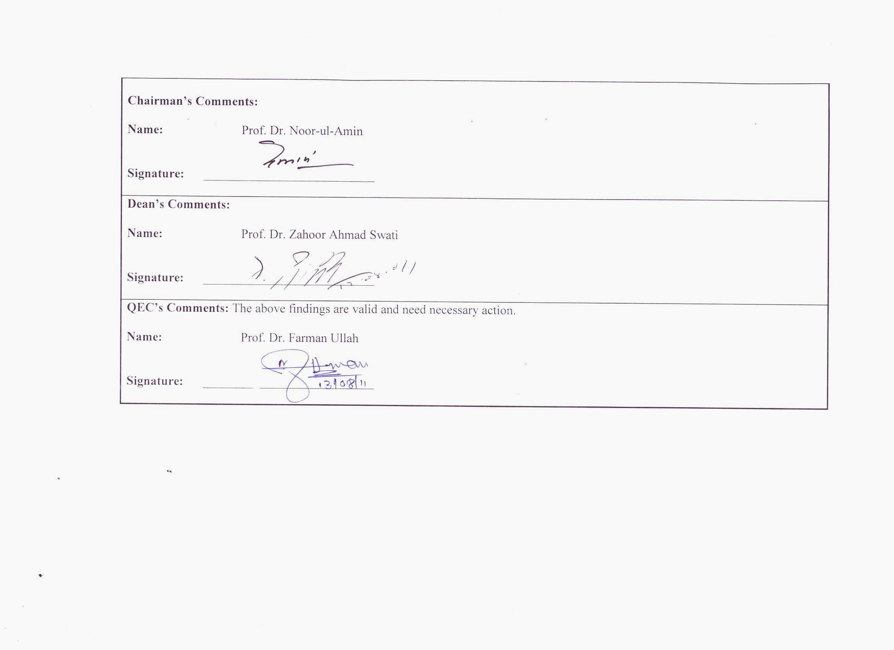
Chairman’s Comments:

Name: Prof. Dr. Noor-ul-Amin

Signature: ___________________________

Dean’s Comments:

Name: Prof. Dr. Zahoor Ahmad Swati

Signature: ___________________________

QEC’s Comments: The above findings are valid and need necessary action.

Name: Prof. Dr. Farman Ullah

Signature: ___________________________

